Selecting the EBS volume you want to delete

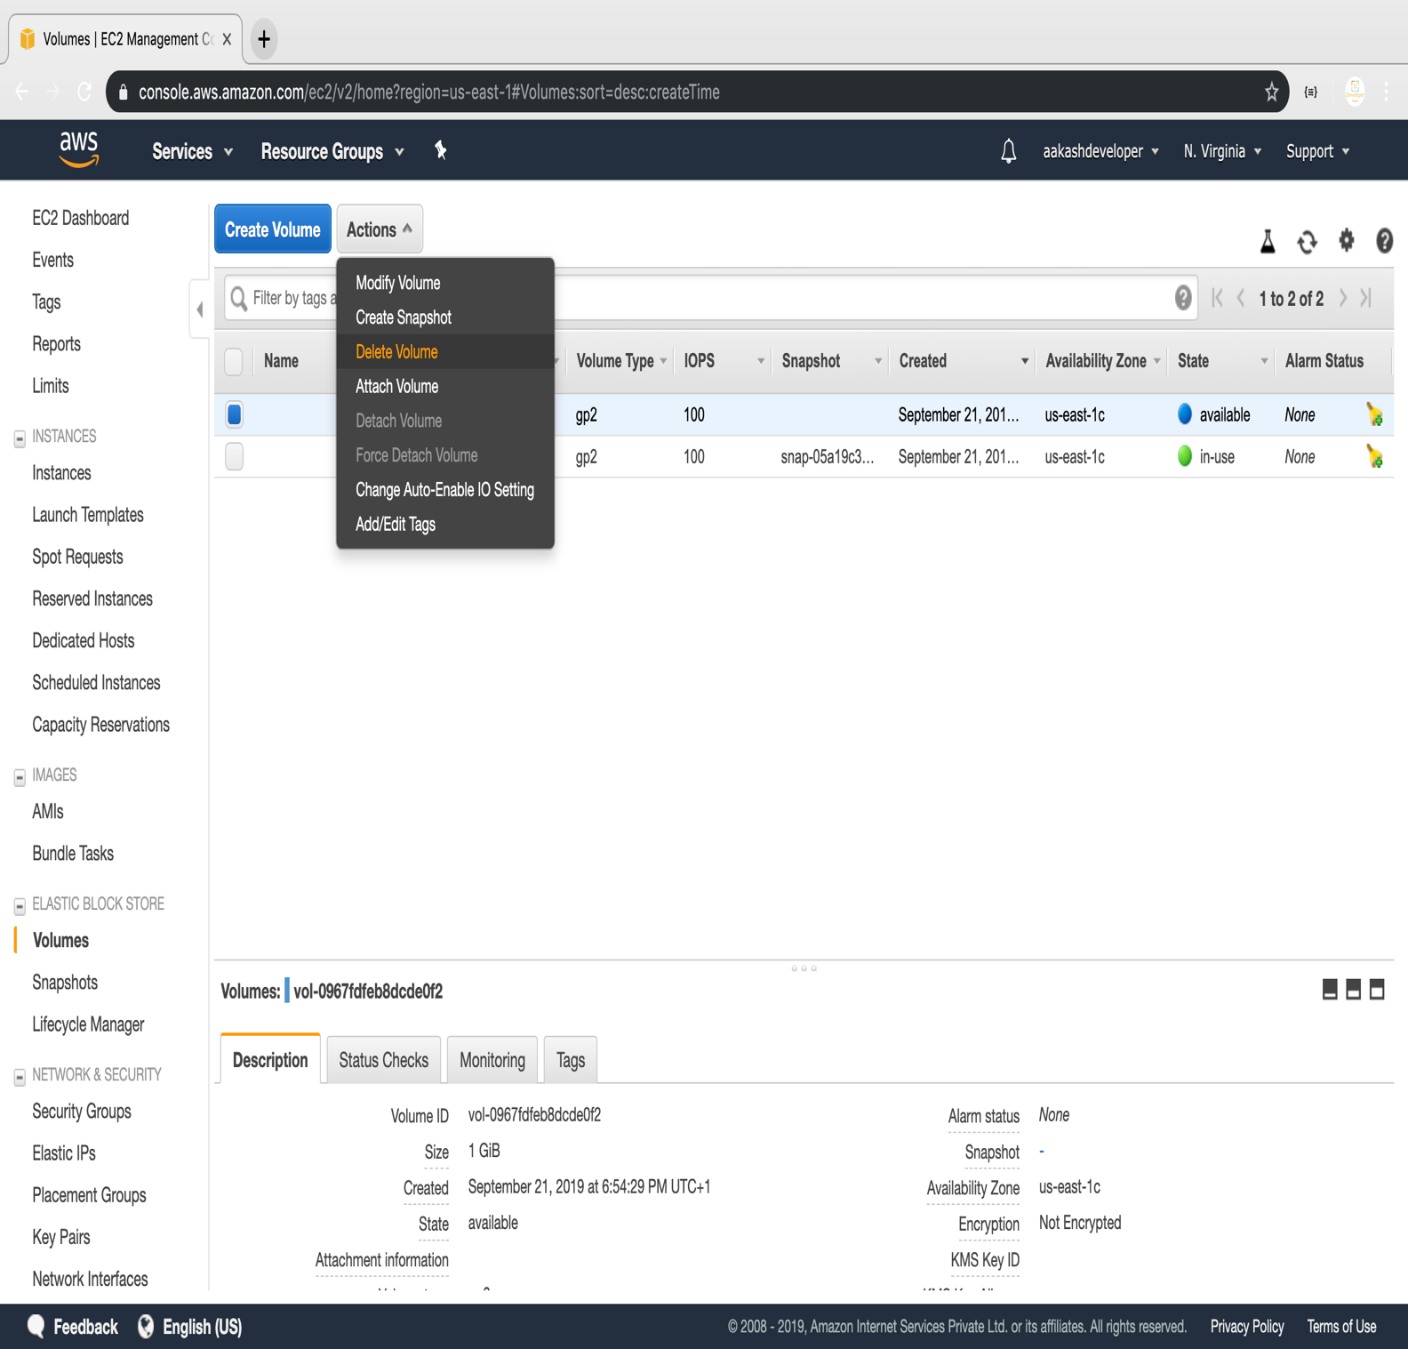

**Step 3.7.2:** Deleting the volume

